**Introduction to Microsoft Azure**

**Features of Free Tier Account**

1. **For Windows & Linux Machines – 750 hours are free.**
2. **Virtual machine type recommended for Free tier account B1S VM.**
3. **Disks Management**
4. **Blob Storage – 5 GB free (Local Redundant Storage)**
5. **File Storage – 5 GB Free**
6. **SQL – 250 GB Free**
7. **Bandwidth Usage – 15 GB Free**
8. **Deployment Models**
9. **Classic Deployment Models**

**In this model each resource existed independently.**

1. **Resource manager**

**Resource Manager which added the concept of resource group in 2014.**

**Resource Manager Terminology**

**A manageable item that is available through Azure**

**Ex: Virtual machine, Storage, account, web apps.**

**Resource Group:**

**A container that holds related resources for an Azure solution**

* **Azure Access Platform**
* **Azure Portal**
* **It is used to view and manage all of your applications in one unified hub. It including web apps, databases, virtual machines, virtual networks, storage, and Visual Studio team projects.**
* **Azure CLI**
* **Azure Bash Shell**
* **Azure Power shell**
* **Azure SDK**
* **Azure Free Account**

|  |  |
| --- | --- |
| **Products** | **Period of free Avail** |
| **750hr of B1s VM for Win Server** | **12 months** |
| **750hr of B1s VM for Linux Server** | **12 months** |
| **128 GB of Managed Disks as a combination of two 64GB** | **12 months** |
| **SSD storage, plus 1GB snapshot and 2 million I/O operations.** | **12 months** |
| **5GB of LRS-Hot Blob storage with 2 million reads, 2 million write Operations.** | **12 months** |
| **250 GB of SQL Database standard** | **12 months** |
| **5GB of bandwidth for outbound data transfer with free unlimited inbound transfer** | **Always Free** |
| **More Services** | **Always Free** |

**Prerequisite to create Azure Free trial account**

1. **You should have email id on outlook.com**
2. **Credit Card (if you have already created Azure account by using existing credit card please try with another credit card to get Free Trial)**
3. **Mobile Number (if you have already created Azure account by using existing mobile number please try with another credit card to get Free Trial)**
4. **Need to register for Free Trial account by using below mentioned URL** [**https://azure.microsoft.com/en-us/free/**](https://azure.microsoft.com/en-us/free/)

**Create Azure Free Account today and you will get Rs.13,300/- credit in your Free trial account to utilize the features of Azure for 30 days. After 30 days of free trial period it will be expired. Then you need the subscription as Pay-As-You-Go**

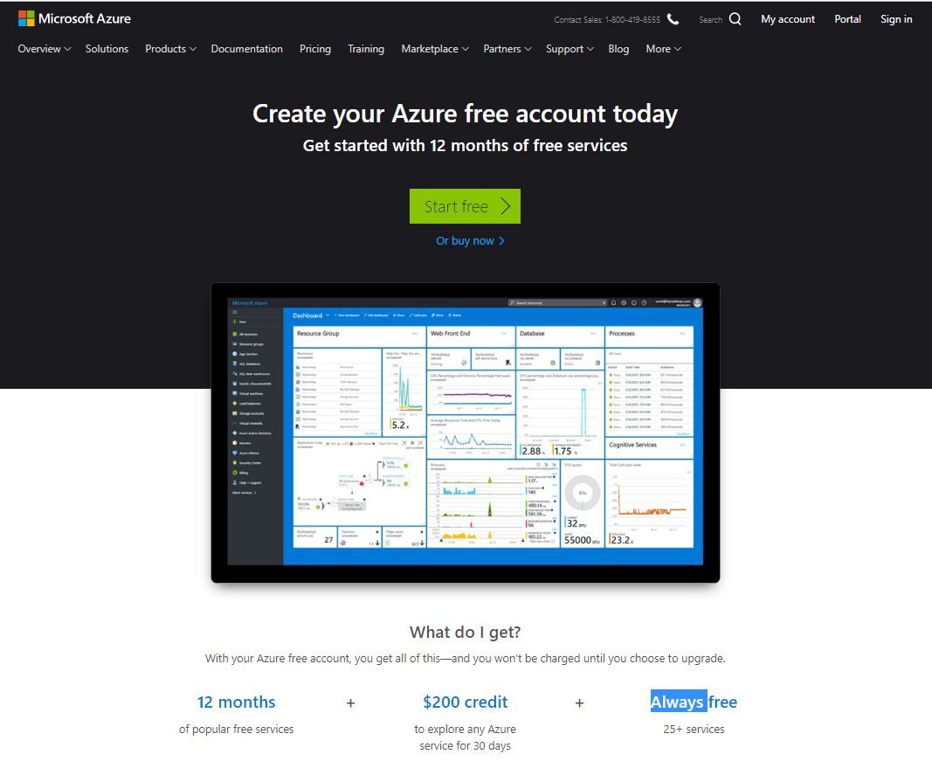

**List of Products are free for 12 months.**

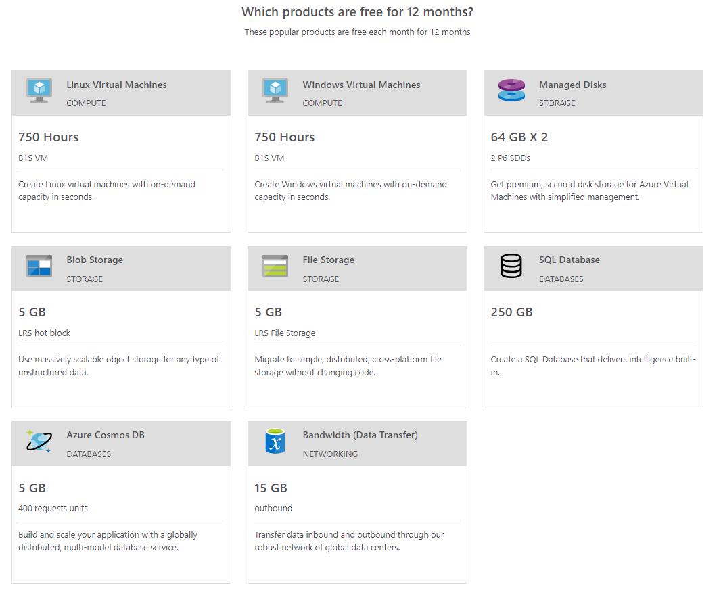

**Below mentioned products are always free**

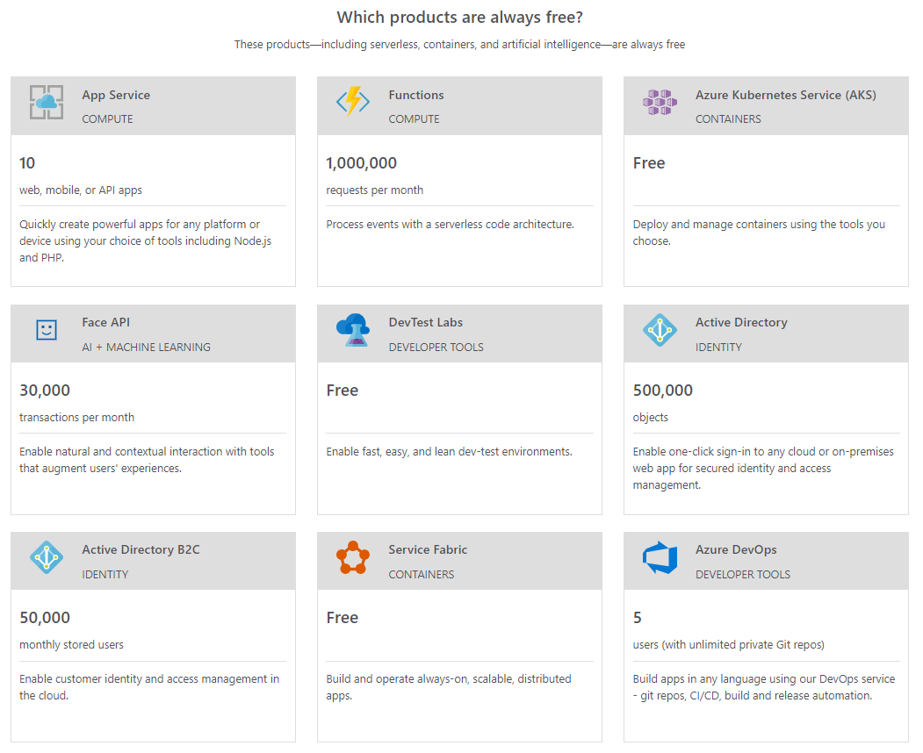

**Below mentioned products are always free**

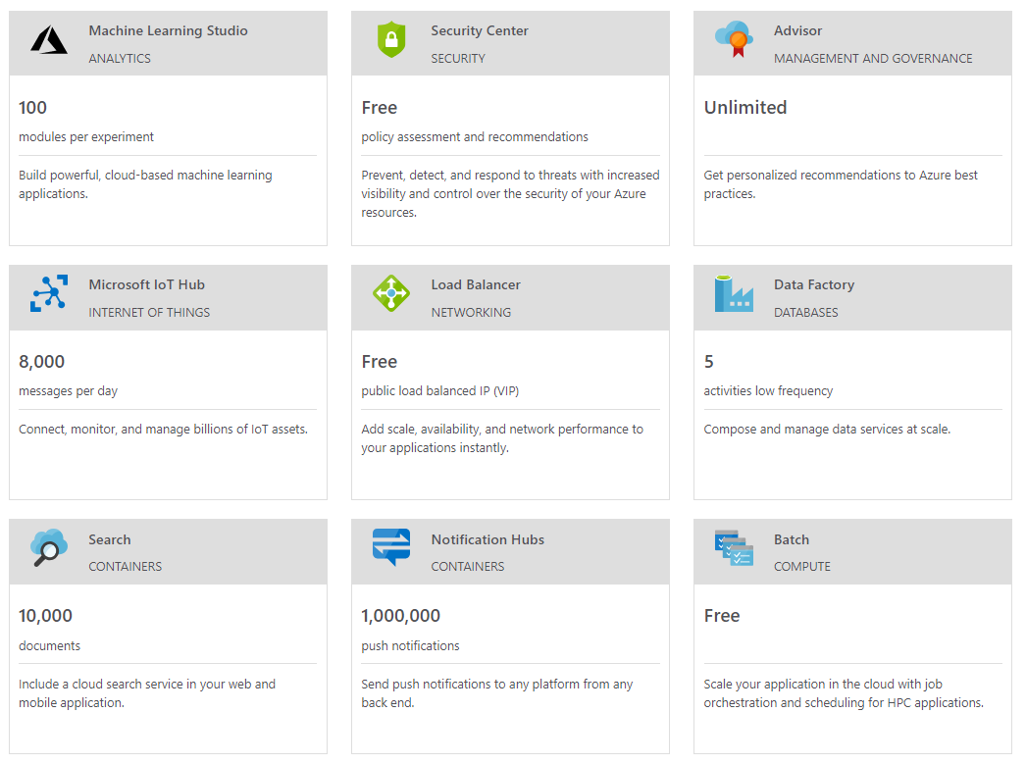

**Below mentioned products are always free**

